# Contact Escalation Page – Email Icon

[**https://www.centurylink.com/home/help/contact/escalation.html**](https://www.centurylink.com/home/help/contact/escalation.html)

**Background on the Issue –**

Customer was sent to a support page that featured an open letter apologizing for their issue and encouraging them to contact support via social media or email. There were icons below the letter that the customer was prompted to click on to do this.

An example of how the page should work when someone clicks on it.

<http://share-na1.app.clicktale.com/?shareId=fc95995b-c66d-47a0-9677-0d804af0599b>

(Notice that even in this clip, the user had to go back and reread the letter to understand what to click.)

The icons are currently placed on the page like this:

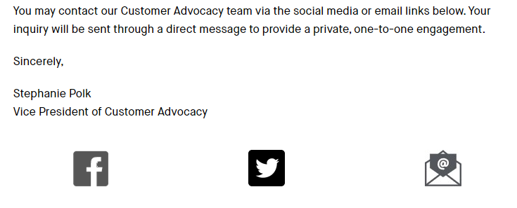

Various Heat Maps show that while about 16% of users click on the email icon, many customers still aren’t getting the help they need from this page.

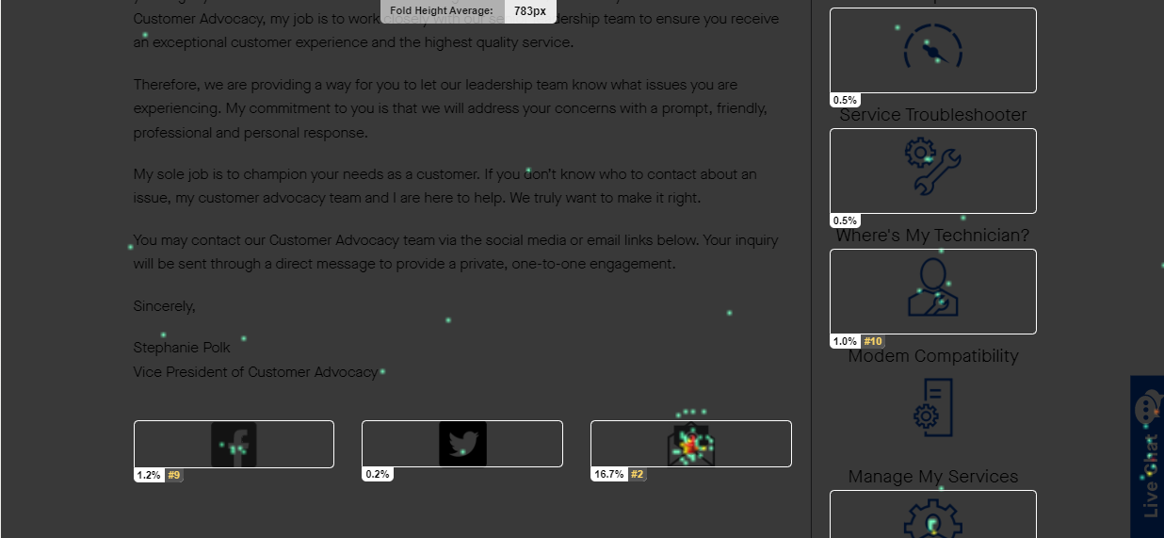

The customer left a comment about the page which stated:



Comment received 5/31/2020.

An example of when a user clicks on the page and doesn’t get the help they need.

<http://share-na1.app.clicktale.com/?shareId=ed700e2f-14b8-4497-85e0-eb444f5477b3>

(Notice in this clip, the user reads the article, but does understand to select one of the icons.)

**Hypothesis –** Even though the content of the letter tells users to click the icons below, some users may not read the letter fully. It may also be unclear to some users that they are supposed to click on the buttons below.

## Possible Solutions

**Solution 1**

Offer prompts under each logo. So, Facebook icon has “Contact us via Facebook” under or over it, Twitter has “Contact us via Twitter” under or over it, and the Email icon has “Contact us via Email” under or over it.

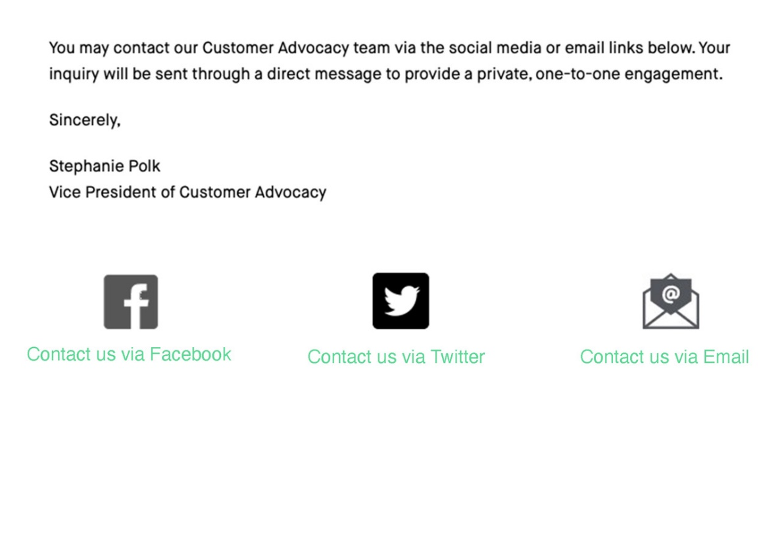

**Solution 2**

Adding a bold header/phrase that says something like “Click the icons below to Contact Us”.

This phase could be bolded, in a different color, or just bigger. Something to help to stand out.

The placement of the phrase could be below the letter and above the buttons.

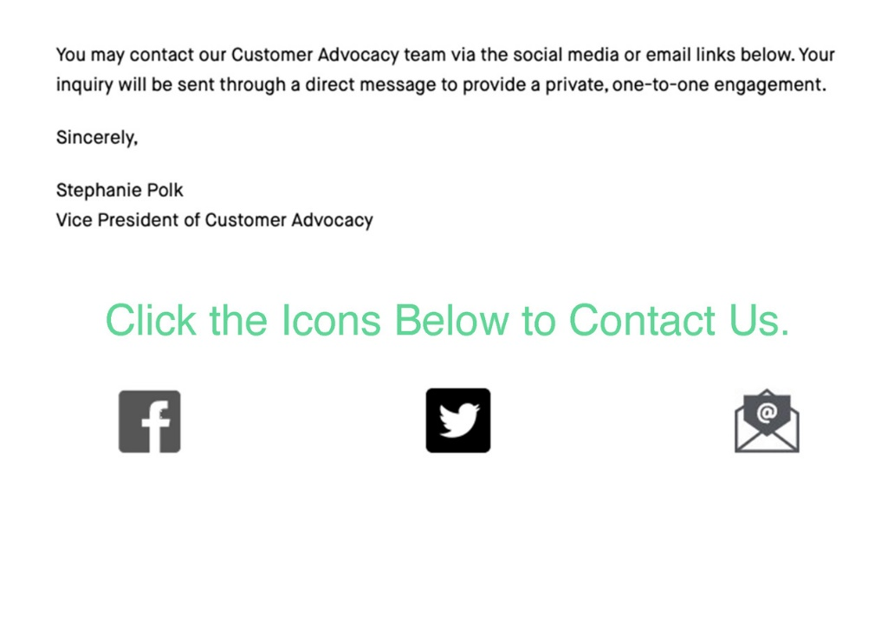

# Contact Escalation Page – Email Icon – Mobile Version

[**https://www.centurylink.com/home/help/contact/escalation.html**](https://www.centurylink.com/home/help/contact/escalation.html)

**Background on the Issue –**

As with the same issue above, customers who visit this page on their mobile devices, are experiencing the same problem when it comes to the layout of the email and social media icons.

Mobile view of the Contact Escalation page.

As you can see from the screenshot above, there are a few key issues with the page. While some mobile users are experiencing the same issues as web users, when it comes to not being able to identify the email icon, another potential issue with this page is the set up of the social media and email icons.

An example of when a user clicks on the page and doesn’t get the help they need.

<http://dmz29.app.clicktale.com/Player2.aspx?PID=8&UID=2812312413389495&SID=2812322130493498&traffictype=Mobile>

Mobile view of the Content Escalation page when the device is turned sideways.

If the user were to turn their mobile device sideways to read the page, the icons would then shift like this. Both methods of viewing on mobile prove to be potentially confusing for the user.

A heatmap from the mobile version of the Contact Escalation page shows that just 6.4% of users click on the email Icon. The percentage of users that click on the social media help icons is around 2.4%.

**Out of all users that scroll through the Contact Escalation page, only 8.8% of people can get the help they need from the icons provided.**

**Hypothesis –** As with the web version, there is some customer confusion on the use of the email icon. There could also be potential customer confusion when it comes to the close layout of the social media and email icons on the mobile version of the page.

## Possible Solutions – Mobile Version

**Solution 1**

Much like Solution 1 of the web version, we could offer prompts under each logo. The main difference with the mobile version is that we would move the icons from a vertical to a horizontal orientation, like the way they are presented in the web version. The result could potentially look something like the following:

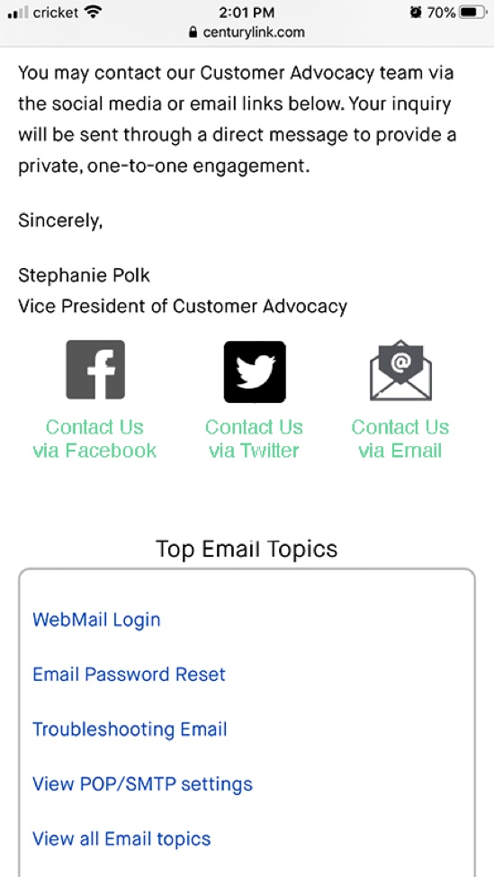

**Solution 2**

Much like the web version, we could include a bold header/phrase above the icons that says something like “Click the icons below to Contact Us.” We could also spread out the icons a bit more to make the page more visually comprehensive to the user. The result could look something like this:

